SM3_method **– Description of methods – Figure and tables**

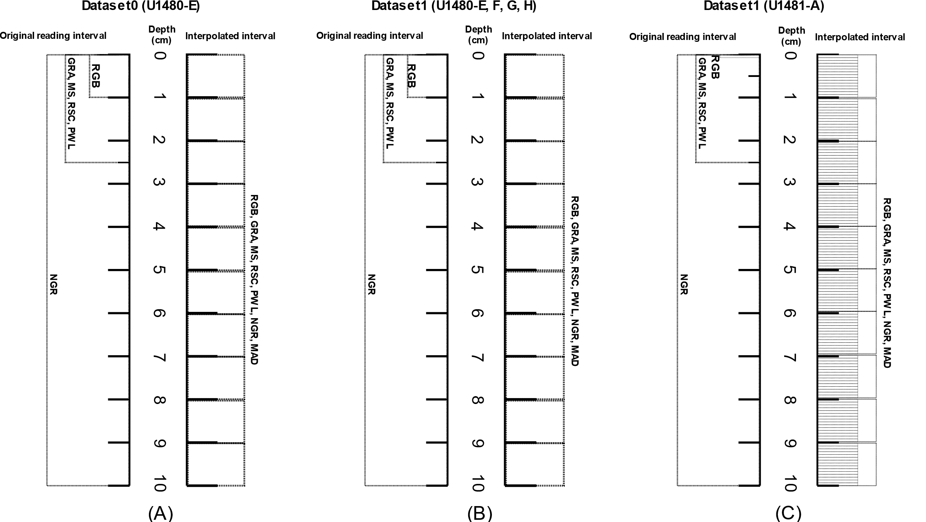

Figure 1 Original reading interval of the geophysical properties according to the formation of the dataset. Dataset0 is formed by the original values of the geophysical properties GRA, MS, RSC, PWL, NGR and RGB with values interpolated at a depth of 1 cm on site U1480, Hole E. Dataset1 (B) is formed by the original values of the geophysical properties GRA, MS , RSC, PWL, NGR and RGB with values interpolated at a depth of 1 cm on site U1480, Holes E, F, G, H. Dataset1 (C) is formed by the original values of the geophysical properties GRA, MS, RSC, PWL, NGR and RGB with values interpolated at a depth of 0.04 cm and 1 cm at site U1481, Hole A. Original value for the MAD geophysical property follows a different reading pattern than other properties.

Table 1: Organization, division and grouping of images IODP-Expedition 362 according to site, hole, total of original images, annotated images and lithology group.

|  |  |  |  |  |
| --- | --- | --- | --- | --- |
| **Site** | **Hole** | **Total Original Images** | **Annotated Images** | **Lithologies present by Groups (cod_lit)** |
| U1480 | E | 81 | 179 | Group 1:  0, 2, 3, 5, 8, 9, 11, 12, 13  Group 2:  0, 1, 2, 3, 4, 5 |
| F | 257 | 622 | Group 1:  0, 1, 2, 3, 5, 8, 9, 10, 11, 12, 13  Group 2:  0, 1, 2, 3, 4, 5 |
| G | 247 | 746 | Group 1:  0, 1, 2, 3, 5, 6, 8, 9, 10, 11, 12, 13  Group 2:  0, 1, 2, 3, 4, 5 |
| H | 100 | 197 | Group 1:  0, 1, 2, 3, 5, 8, 9, 10, 11, 12, 13  Group 2:  0, 1, 2, 3, 4, 5 |
| U1481 | A | 128 | 857 | Group1:  0, 1, 2, 3, 5, 8, 9, 10, 11, 12, 13  Group 2:  0, 1, 2, 3, 4, 5 |

Table 2: Division of lithologies by group and dataset with number of records interpolated by the Akima interpolator

|  |  |  |  |  |  |  |  |
| --- | --- | --- | --- | --- | --- | --- | --- |
| **Group** | **Cod_lit** | **Lithology or Group Litology** | **Record Dataset0: U1480-E** | **Record Dataset1:**  **U1480** | **Record Dataset1:**  **U1481** | **Record Dataset2:**  **U1480** | **Record Dataset2:**  **U1481** |
| 1 | 0 | Alternating sand/sandstone and  mud/mudstone layers | 1046 | 7130 | 3626 | 6193 | 402 |
| 1 | Alternating silt/siltstone and  clay/claystone layers | 0 | 12776 | 78035 | 10823 | 6142 |
| 2 | Ash/tuff | 3 | 258 | 163 | 175 | 7 |
| 3 | Calcareous clay/claystone | 3330 | 5880 | 21 | 4020 | 0 |
| 4 | Calcareous silt/siltstone | 0 | 0 | 0 | 0 | 0 |
| 5 | Clay/claystone | 3833 | 22963 | 51347 | 18563 | 3893 |
| 6 | Coarse sand/sandstone | 0 | 38 |  | 42 | 0 |
| 7 | Conglomerate | 0 | 0 | 0 | 0 | 0 |
| 8 | Fine sand/sandstone | 1508 | 11120 | 17567 | 9770 | 1619 |
| 9 | Medium sand/sandstone | 2816 | 4232 | 10151 | 2856 | 808 |
| 10 | Sand/sandstone-silt/siltstone-clay/  claystone | 0 | 472 | 0 | 436 | 0 |
| 11 | Silt/Siltstone | 461 | 11524 | 5801 | 1895 | 487 |
| 12 | Silty clay/claystone | 349 | 2280 | 34032 | 9492 | 2771 |
| 13 | Very fine sand/sandstone | 2634 | 5336 | 11193 | 3729 | 935 |
| 2 | 0 | Group 1, cod_lit: 0, 1, 10 (Alternating layers) |  | 20378 | 81661 | 17452 | 6544 |
| 1 | Group 1, cod_lit: 2 (Ash/tuff) |  | 258 | 163 | 175 | 7 |
| 2 | Group 1, cod_lit: 3 (Calcareous clay/claystone) |  | 5880 | 21 | 4020 | 0 |
| 3 | Group 1, cod_lit: 5 (Clay/claystone) |  | 22963 | 51347 | 18563 | 3893 |
| 4 | Group 1, cod_lit: 11, 12 (Silt/Clay) |  | 13804 | 39833 | 11387 | 3258 |
| 5 | Group 1, cod_lit: 6, 8, 9, 13 (Sand) |  | 20726 | 38911 | 16397 | 3362 |

Table 3: Interpolation intervals separated at site U1480 and site U1481 using the defined interpolator. The lowest reading resolution on the sites U1480 and U1481 is in the RGB geophysical property.

|  |  |  |  |
| --- | --- | --- | --- |
| **Site** | **Interpolador** | **Depth range for interpolation** | **Lower reading resolution** |
| U1480 | Akima | 1,00 cm | 1,00 cm |
| U1481 | Akima | 1,00 cm | 0,04 cm |

Table 4: Original records and interpolated records by Akima separated by site and core in each geophysical property used. The total number of records interpolated in U1480-E: 15980, U1480-F: 16538, U1480-G: 33876, U1480-H: 17615, totaling 84009. For the original records, the sum of records does not meet in all depths. In U1480-F, the RGB geophysical property does not require interpolation. The total number of records interpolated in U1481-A: 211936. For the original records, the sum of records does not meet in all depths. In U1481-A, the RGB geophysical property does not require interpolation.

|  |  |  |  |
| --- | --- | --- | --- |
| **Site** | **Hole** | **Original**  **Records** | **Interpolated Records** |
| U1480 | E | GRA – 3333  MAD – 125  MS – 3333  NGR – 810  PWL – 3253  RGB – 8314  RSC – 3081 | GRA – 12647  MAD – 15855  MS – 12647  NGR – 15170  PWL – 12727  RGB – 7666  RSC – 12899 |
| F | GRA – 8108  MAD – 166  MS – 8108  NGR – 1885  PWL – 6636  RGB – 19815  RSC – 6806 | GRA – 8430  MAD – 16372  MS – 8430  NGR – 14653  PWL – 9902  RGB – -3277  RSC – 9732 |
| G | GRA – 8753  MAD – 305  MS – 8753  NGR – 2066  PWL – 5578  RGB – 20940  RSC –10787 | GRA – 25123  MAD – 33571  MS – 25123  NGR – 31810  PWL – 28298  RGB – 12936  RSC – 23089 |
| H | GRA – 4135  MAD – 107  MS – 4135  NGR – 994  PWL – 3530  RGB – 10230  RSC – 4099 | GRA – 13480  MAD – 17508  MS – 13480  NGR – 16621  PWL – 14085  RGB – 7385  RSC – 13516 |
| U1481 | A | GRA – 4679  MAD – 172  MS – 4679  NGR – 1123  PWL – 3371  RGB – 250162  RSC – 4632 | GRA – 207257  MAD – 211764  MS – 207257  NGR – 210813  PWL – 208565  RGB – -38226  RSC – 207304 |

Table 5: Formation of datasets with number of records per group and number of features used.

|  |  |  |  |  |  |  |
| --- | --- | --- | --- | --- | --- | --- |
| **Dataset** | **Site-Hole** |  | **Group** | **Quantity interpolated records** | **Quantity features** | **Record interval** |
| Dataset0 | U1480-E |  | 1 | 15980 | 17 | depending on the interpolation configuration |
| Dataset1 | U1480-E,F,G,H |  | 1 | 84009 | 17 | depending on the interpolation configuration |
| Dataset1 | U1480-E,F,G,H |  | 2 | 84009 | 17 | depending on the interpolation configuration |
| Dataset1 | U1481-A |  | 1 | 211936 | 17 | depending on the interpolation configuration |
| Dataset1 | U1481-A |  | 2 | 211936 | 17 | depending on the interpolation configuration |
| Dataset2 | U1480-E,F,G,H |  | 1 | 67994 | 90 | according to the segmentation interval via SLIC |
| Dataset2 | U1480-E,F,G,H |  | 2 | 67994 | 90 | according to the segmentation interval via SLIC |
| Dataset2 | U1481-A |  | 1 | 17064 | 90 | according to the segmentation interval via SLIC |
| Dataset2 | U1481-A |  | 2 | 17064 | 90 | according to the segmentation interval via SLIC |